

Name: Adil Khan

Department: BS AI

Roll no: 2330-0030

Subject: Object Oriented Programming

Teacher: Mam Saba Awan

Lab no 8

Task no 1:

#include <iostream>

#include <cmath>

using namespace std;

class Circle;

class Rectangle {

private:

double area;

public:

Rectangle(double length, double width) {

area = length * width;

}

friend void compareArea(const Rectangle& r, const Circle& c);

};

class Circle {

private:

double area;

public:

Circle(double radius) {

area = M_PI * radius * radius;

}

friend void compareArea(const Rectangle& r, const Circle& c);

};

void compareArea(const Rectangle& r, const Circle& c) {

cout << "Rectangle area: " << r.area << endl;

cout << "Circle area: " << c.area << endl;

if (r.area > c.area)

cout << "Rectangle has a larger area." << endl;

else if (r.area < c.area)

cout << "Circle has a larger area." << endl;

else

cout << "Both areas are equal." << endl;

}

int main() {

Rectangle rect(10, 5);

Circle circ(4);

compareArea(rect, circ);

return 0;

}

Output:

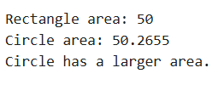

Task no 2:

#include <iostream>

using namespace std;

class Engine;

class Car {

private:

int horsepower;

public:

Car(int hp) : horsepower(hp) {}

void displayHorsepower() const {

cout << "Car horsepower: " << horsepower << endl;

}

friend class Engine;

};

class Engine {

public:

void boostHorsepower(Car& c, int increase) {

c.horsepower += increase;

cout << "Horsepower increased by " << increase << " using Engine." << endl;

}

};

int main() {

Car myCar(150);

Engine myEngine;

myCar.displayHorsepower();

myEngine.boostHorsepower(myCar, 50);

myCar.displayHorsepower();

return 0;

}

Output:

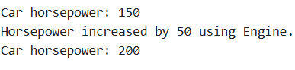

Task no 3:

#include <iostream>

using namespace std;

class Counter {

private:

int count;

public:

Counter(int c) : count(c) {}

void display() const {

cout << "Count: " << count << endl;

}

friend void increment(Counter& c);

};

void increment(Counter& c) {

c.count += 1;

cout << "Incremented using friend function." << endl;

}

int main() {

Counter myCounter(5);

myCounter.display();

increment(myCounter);

myCounter.display();

return 0;

}

Output:

